Creating Amazon S3 Bucket using CloudFormation

CREATE THE CLOUDFORMATION TEMPLATE
✅ STEP 1: Create a template file on your laptop
- Open Notepad
- Create a new file
- Name it:
- s3-bucket.yaml

✅ STEP 2: Paste THIS EXACT template

AWSTemplateFormatVersion: '2010-09-09'
Description: Create an S3 bucket using CloudFormation

Resources:
MyS3Bucket:
Type: AWS::S3::Bucket

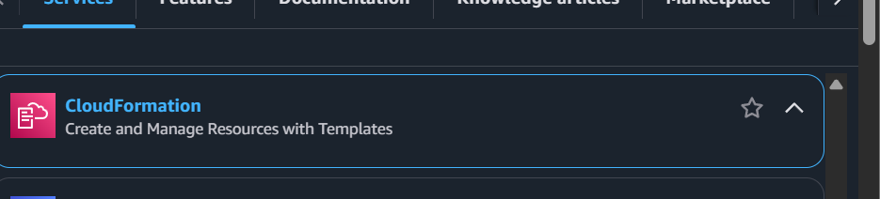

STEP 3: Open CloudFormation
- Go to AWS Console
- Search for CloudFormation
- Click Create stack

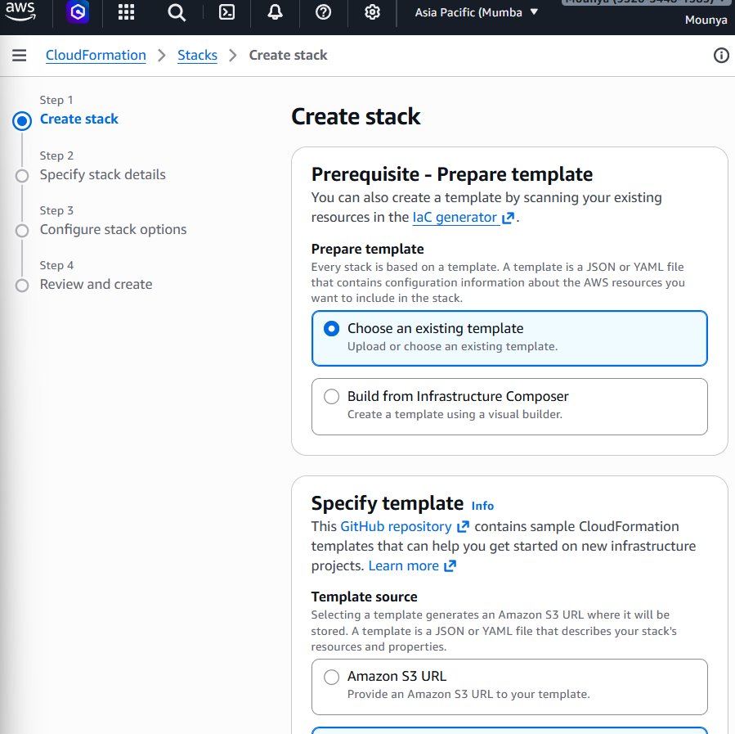

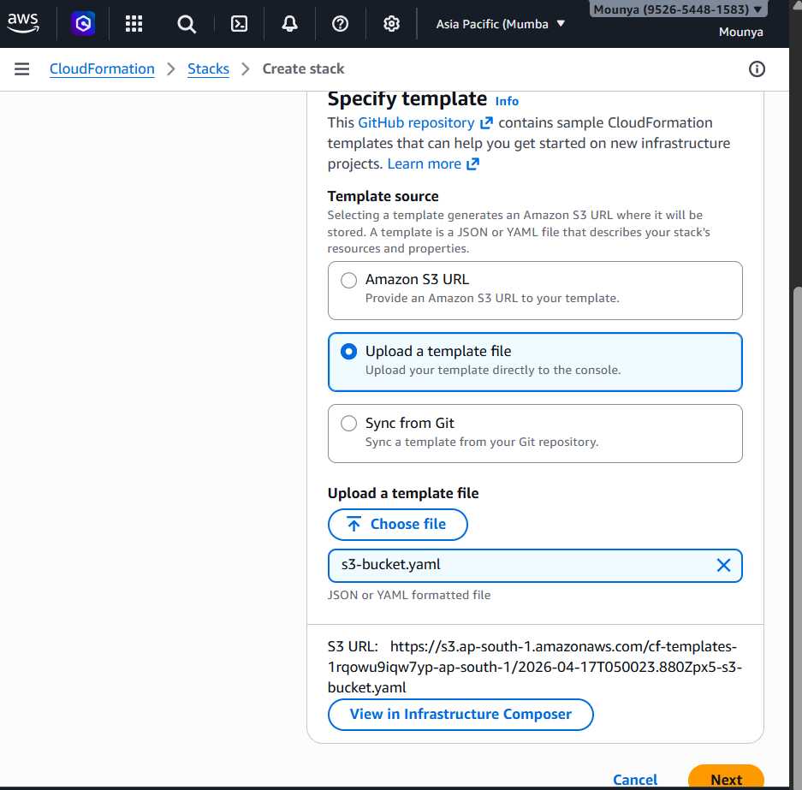

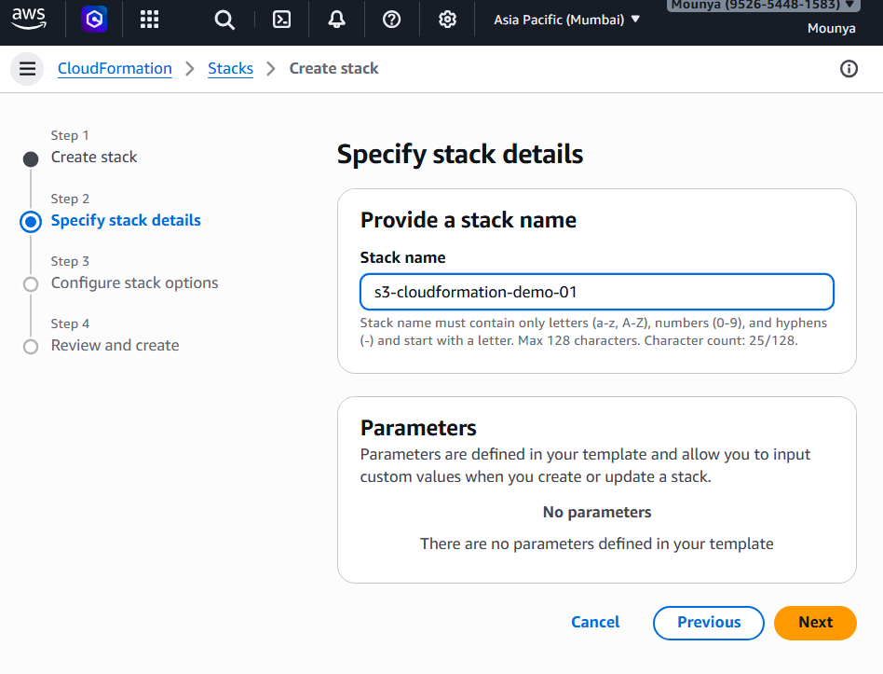

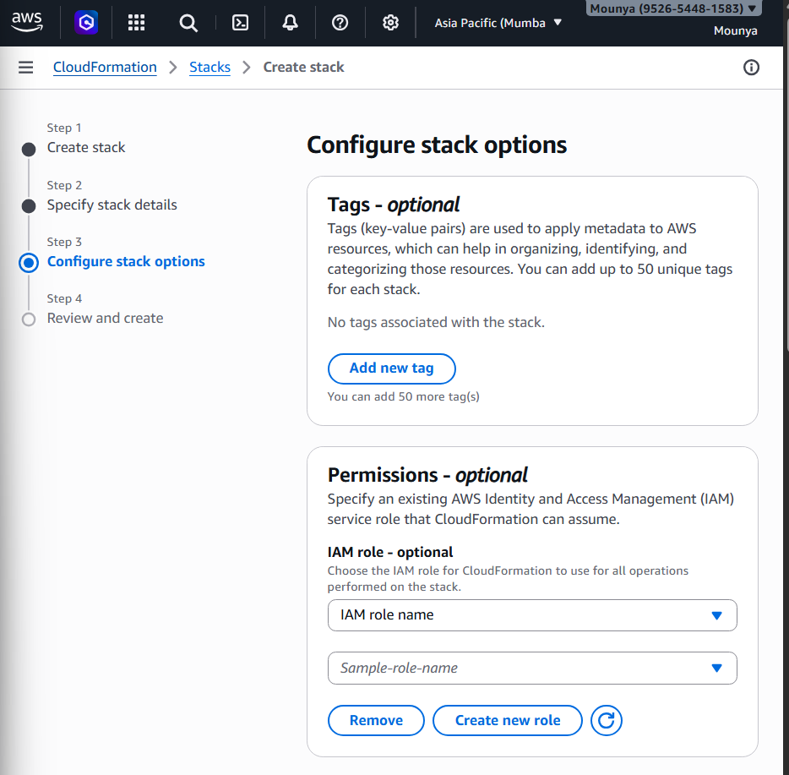

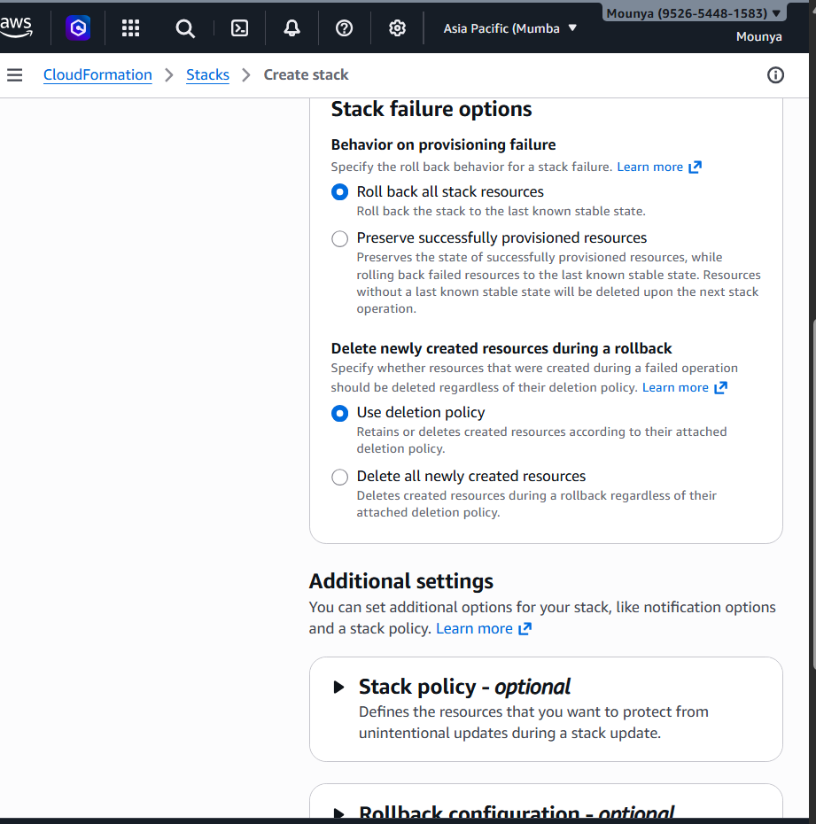

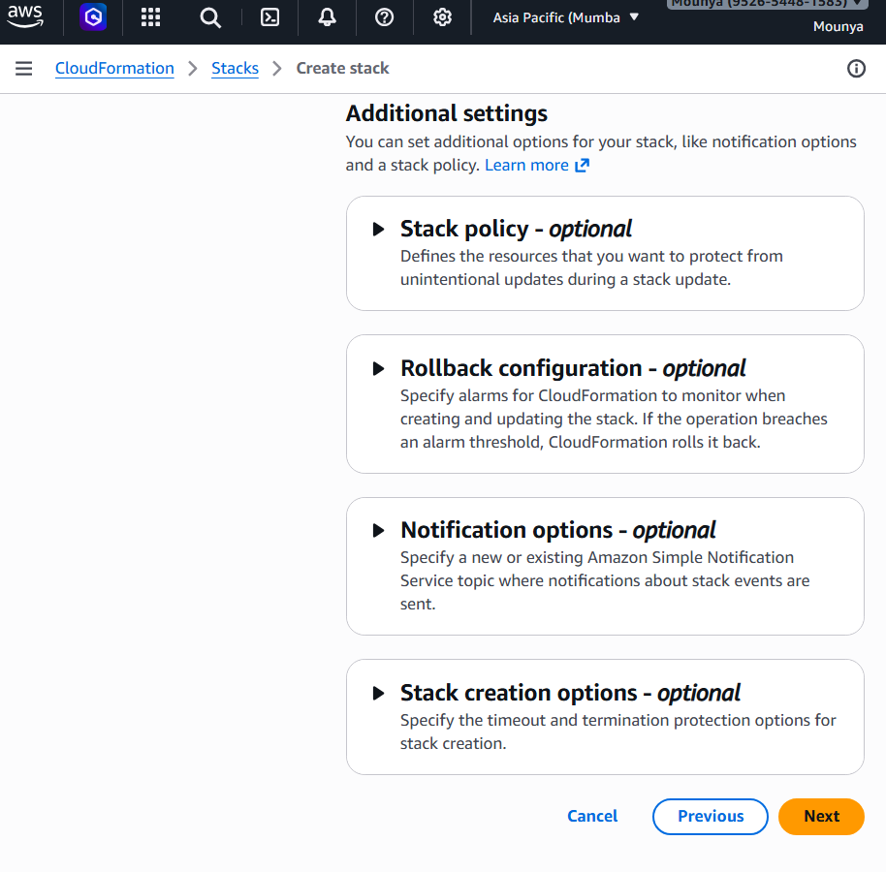

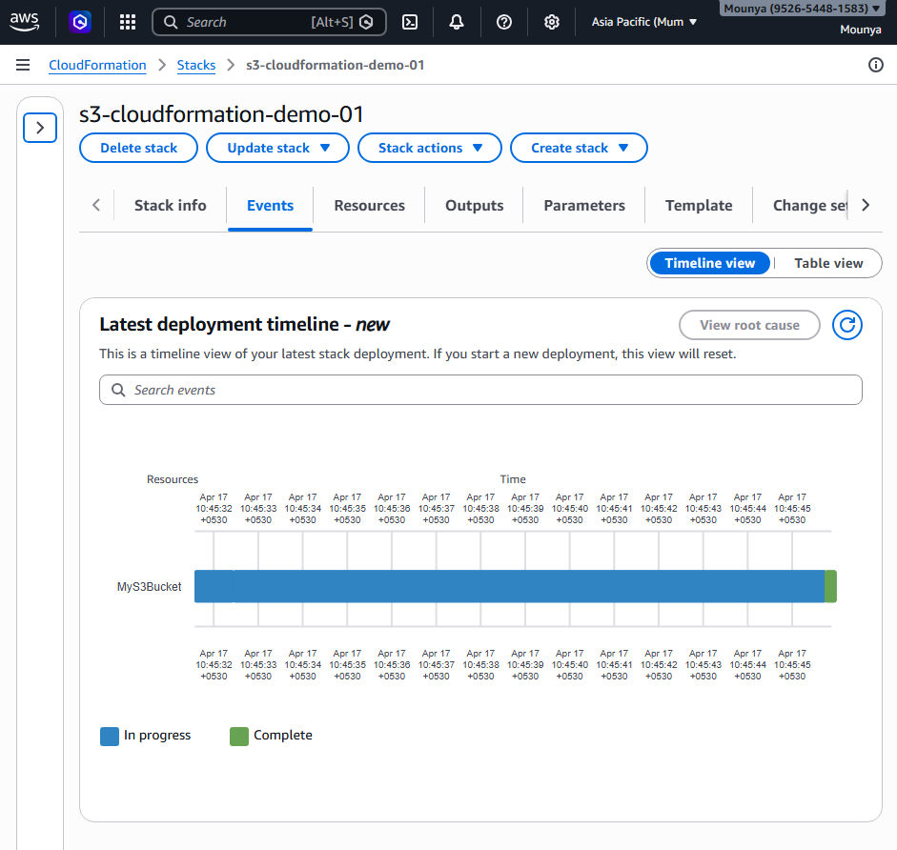

Check the S3 bucket
- Go to S3
- Click Buckets

